**Changes to prescribing of bath and shower preparations**

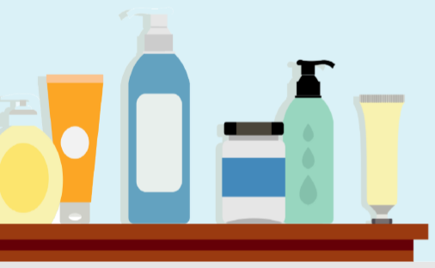

**Information about changes to medicines or treatments on the NHS: Changes to prescribing of bath and shower preparations**

**Contents**

1. [Which bath and shower preparations are affected?](https://www.tudormedicalcentre.nhs.uk/2023/10/24/changes-to-prescribing-of-bath-and-shower-preparations/#nhs-block-anchor-0)
2. [Why will these bath and shower preparations not be prescribed anymore?](https://www.tudormedicalcentre.nhs.uk/2023/10/24/changes-to-prescribing-of-bath-and-shower-preparations/#nhs-block-anchor-1)
3. [What options are available instead of these bath and shower preparations?](https://www.tudormedicalcentre.nhs.uk/2023/10/24/changes-to-prescribing-of-bath-and-shower-preparations/#nhs-block-anchor-2)
4. [Where can I find more information and support?](https://www.tudormedicalcentre.nhs.uk/2023/10/24/changes-to-prescribing-of-bath-and-shower-preparations/#nhs-block-anchor-3)

The NHS will be asking doctors to stop or greatly reduce the prescribing of some treatments. This is because the treatments are:

* Not as safe as other treatments OR
* Not as good (effective) as other treatments OR
* More expensive than other treatments that do the same thing.

**This includes bath and shower preparations for dry and itchy skin conditions.**

This document will explain why the changes are happening and where you can get more information and support.

**Which bath and shower preparations are affected?**

Moisturising bath and shower preparations are bath oils that are poured into the bath water, and bath and shower emollients which can be used to wash the body. These products are used for dry and itchy skin conditions such as eczema.

**Why will these bath and shower preparations not be prescribed anymore?**

A study showed that using pour in the bath emollients did not make any difference to eczema symptoms and therefore using these products is not a good use of NHS resources.

There is no good quality evidence to show that bath and shower emollients are more effective than leave on emollients used as a soap substitute.

There are also risks with using bath emollients such as skin irritation if large amounts are used, particularly if antiseptic bath oils are used.

**What options are available instead of these bath and shower preparations?**

It is still really important to use leave-on emollient moisturisers and avoid soap.

Emollients can be used as a soap substitute. Mix a small amount (around teaspoonful) of emollient in the palm of your hand with a little warm water and spread it over damp or dry skin. Rinse and pat the skin dry, being careful not to rub it.

You can use soap substitutes for handwashing, showering or in the bath. Emollients do not foam like normal soap but are just as effective at cleaning the skin.

**Items which should not routinely be prescribed in primary care – bath and shower preparations for dry and itchy skin conditions**

**Where can I find more information and support?**

* You can speak to your local pharmacist, GP or the person who prescribed the medication to you.
* Your local patient group.
* NHS website <https://www.nhs.uk/conditions/emollients/>
* British Medical Journal. Results of the BATHE study including patient video. <https://www.bmj.com/content/361/bmj.k1332>

Find out more about the medicines that are being stopped or reduced:

<https://www.england.nhs.uk/medicines/items-which-should-not-be-routinely-prescribed/>

**Warning advice: Please note**

If you have any questions about the prescribing of bath and shower prescribing please email them to: [england.medicines@nhs.net](mailto:england.medicines@nhs.net)